Model: HA-2307
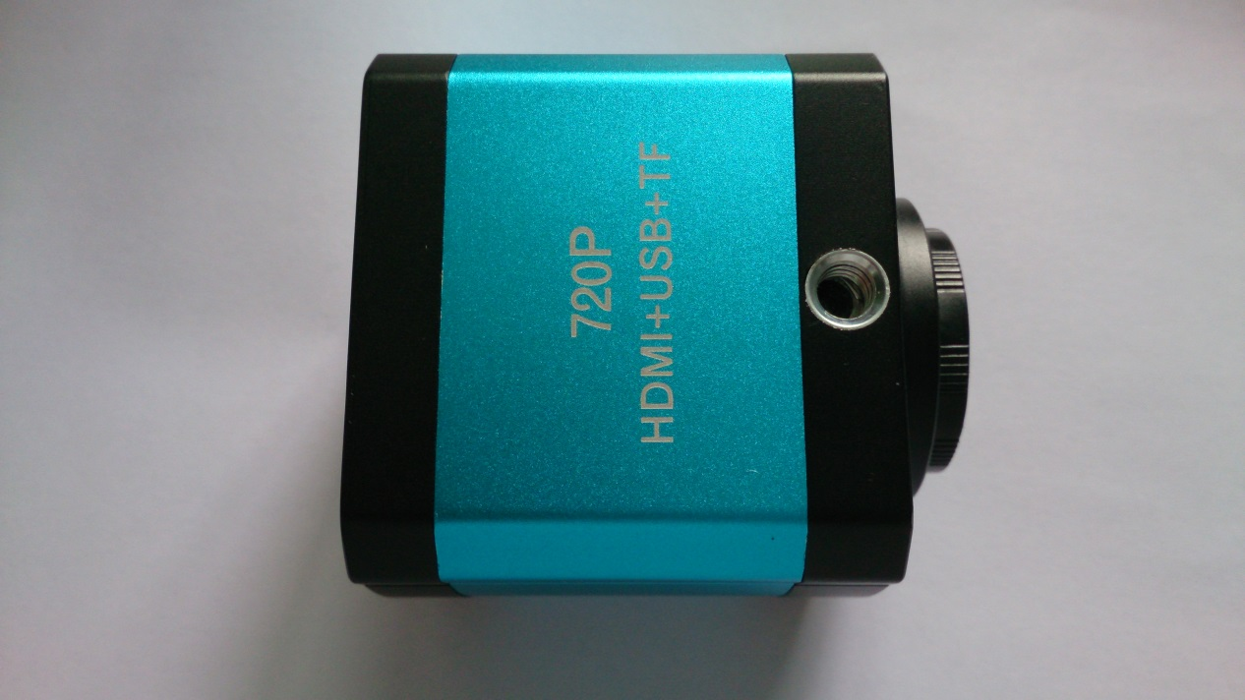
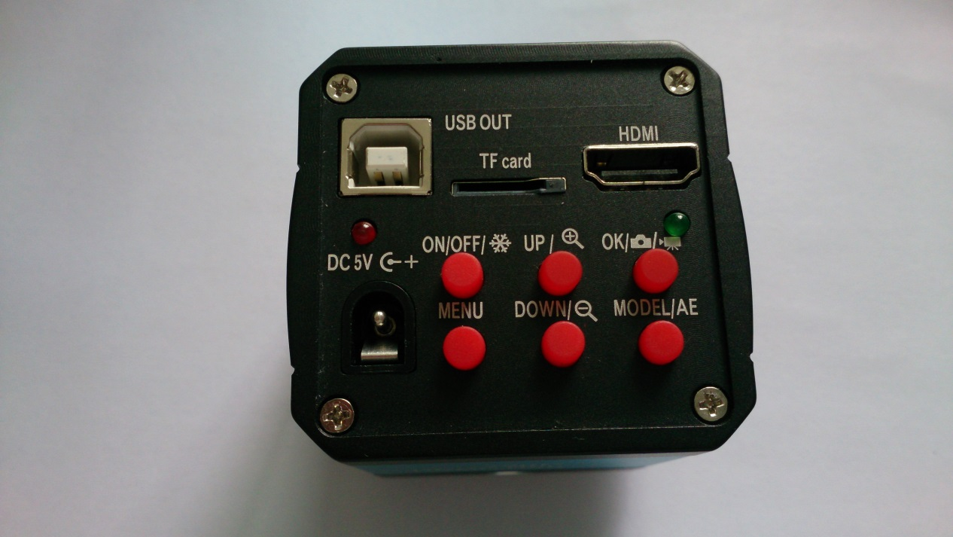
Description:
- 14MP Panasonic COMS sensor
- 14MP snap shot image and 720P video recording. One button switches snap shot & video mode. --- Button “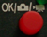”.
- 8 times digital Zoom, press “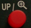” and “” to zoom it.
- Full HD HDMI output, output frequency is 720P, 60Hz.
- Driver free. 1080P@30fps HD USB video output.
- Support one key freeze/unfreeze image. When power on, press once the “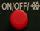” button can achieve the function.
- Support line drawing function. Up to 4 lines on horizontal and vertical which can be movable and set the line color and size. Meanwhile shows the cross line.
- Support auto & menu exposure.
- Support EV adjustment
- Support EN/CH/DE/FR/IT/JP language setting.
- Support 50Hz, 60Hz light source frequency setting
- Support HCSD T-flash card (Class 4), max. 32GB.
- Support to save the function setting after power off

Ports Description:
- HDMI video output
- USB B-type HD video output
- T-flash card port
- DC power adapter port (DC12V 1A)

Buttons Description:
- : On/off (freeze/ unfreeze) button
- 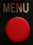: Menu
- : Up/Zoom +
- : DOWN/ Zoom -
- : Snap shot/ video/ ok (confirm)
- 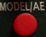: MODEL/ AE (switch mode)

Operation Description:
First Step: Power Supply
Inset the 12V 1A DC power adapter to the DC port.
Noted: USB cable can be powered as well.
Second Step: Power on
Press on/off button, Red indicate light is on, camera works well.
Third Step:
If use HDMI output, camera is under preview state; if USB output with PC, please install S-EYE software first. When use USB output, please remove the TF card from the camera.
Forth Step: Operation
- Snap shot
Under the HDMI output, press “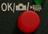” once for one image & save as JPEG format in TF card.
Note 1: Before snap shot a picture, make sure there is a TF card in the camera, not less than 2GB. Otherwise it will show an error.
Note 2: If it is error after inset the TF card or press “”, please enter menu to format TF card.
- Video
Under HDMI output, press “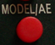”, green indicate light is on, then camera is in video mode. Press “” once, green indicate light is flashing, camera is taking video. The video format is in H.264, 1080P@30fps & save in TF card.
Note 1: Before snap shot a picture, make sure there is a TF card in the camera, not less than 2GB. Otherwise it will show an error.
Note 2: If it is error after inset the TF card or press “”, please enter menu to format TF card.
- Digital Zoom
Under HDMI output, press “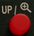” or ”” to zoom & adjust the image size on preview.
- Freeze & Unfreeze
Under HDMI output and preview state, press “” can freeze and unfreeze the image.
- Auto / Manual exposure switch
Under HDMI output & preview state, press “”, camera will switch auto/ manual exposure.
- Lines display
Under HDMI output & preview state, press “”, choose “line set” and you can select display lines or hide lines. If yes, press and to quick menu. Then the camera will show 4 lines on horizon & 4 lines on vertical.
- Lock & move the lines
Under HDMI output & preview state, press and choose “line set”, you can set the Line/ Line DIR, Line Position, Line color & Line weight per needed.
Noted 1: Enter “Line set” --- Cross Hair on ( press )-- show the cross hair on the center
Noted 2: Enter “Line”, press to select 1-8 lines show one the screen
Noted 3: Line DIR, press to switch VER or HOR
Noted 4: Line Position, press or to move the line position
Noted 5: Line color, press to select the line color
Noted 6: Line weight, press to select the line weight
- Language Setting
Under HDMI & preview state, press , move to Language and enter, you can select display language: English/ French/ Dutch/ 简体中文/繁体中文/Japanese/ Spanish
- Frequency
Under HDMI & preview state, press & choose frequency, you can choose 50Hz or 60Hz light source. Press and save. Press to quit
- Exposure
Under HDMI & preview state, press & choose exposure, press or to adjust the exposure. Press to save
- Format
Under HDMI & preview state, press & choose format, system will remind user about format the TF card.
NOTED: Be careful to use the FORMAT function, it will clear all data of the TF card which inset the camera.
- Default
Under HDMI & preview state, press & choose Default, press to default setting
Noted: It will clear all settings after you default the camera.

Power off:
Press & hold for a few second, camera will save all settings and power off. The red indicate light is off. Please remove power adapter

